
Experiment (10)

Border Gateway Protocol (BGP)
  - Objectives

To achieve imporance of BGP
Border Gateway Protocol (BGP)

  - Equipment / Program Requirements:
Ensp
Cisco packet tracker

  - Experiment Setup:
Make topology
Then put ips for each device
Then configuration BGP Protcol Interior Then Ping For Troubleshooting

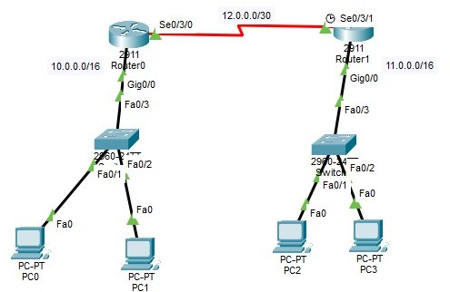
  - Simulation Results: Cisco Paket Traker: Topology

Router 0 Configurtaion:

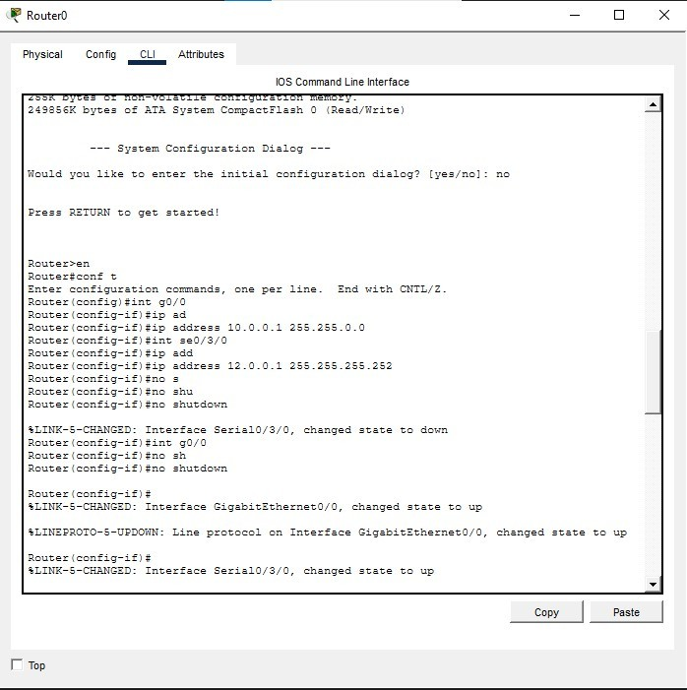

Router 0 Routing Table :

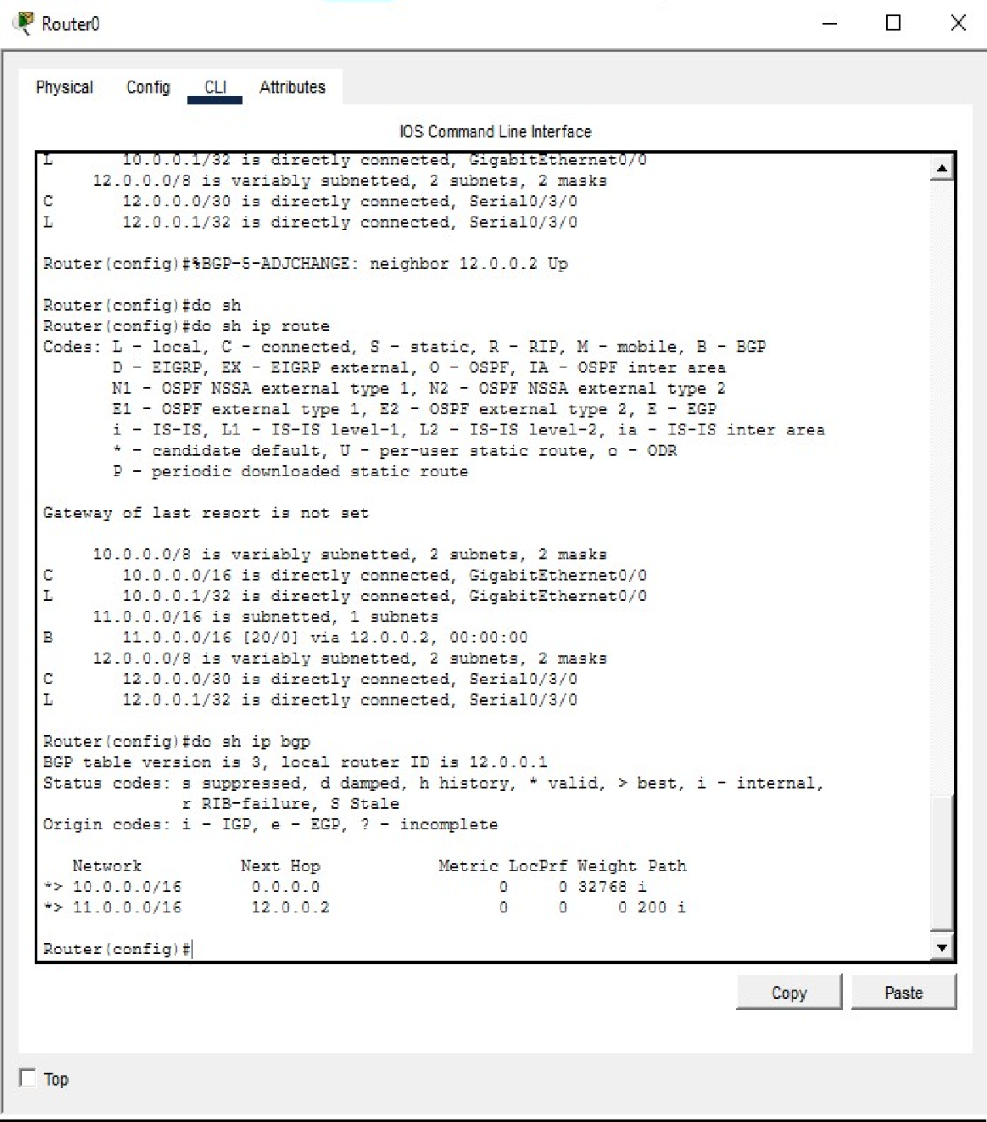

Router 1 Configuration:

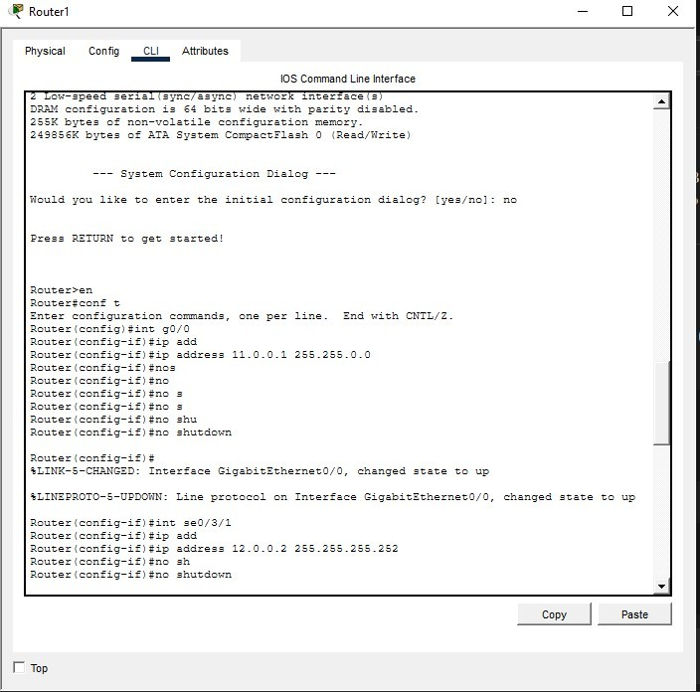

Router 1 Routing Table:

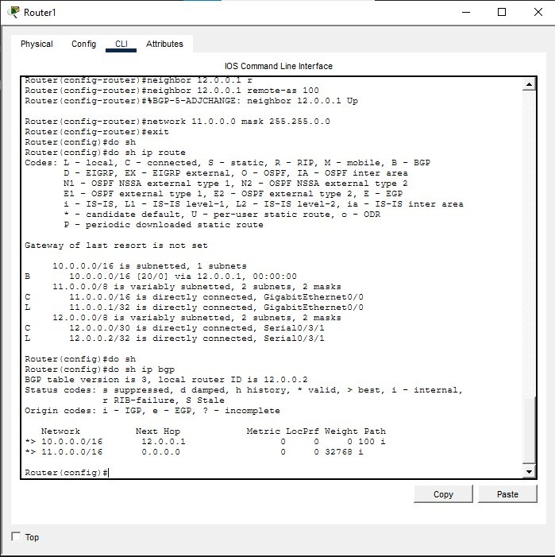

Testing:

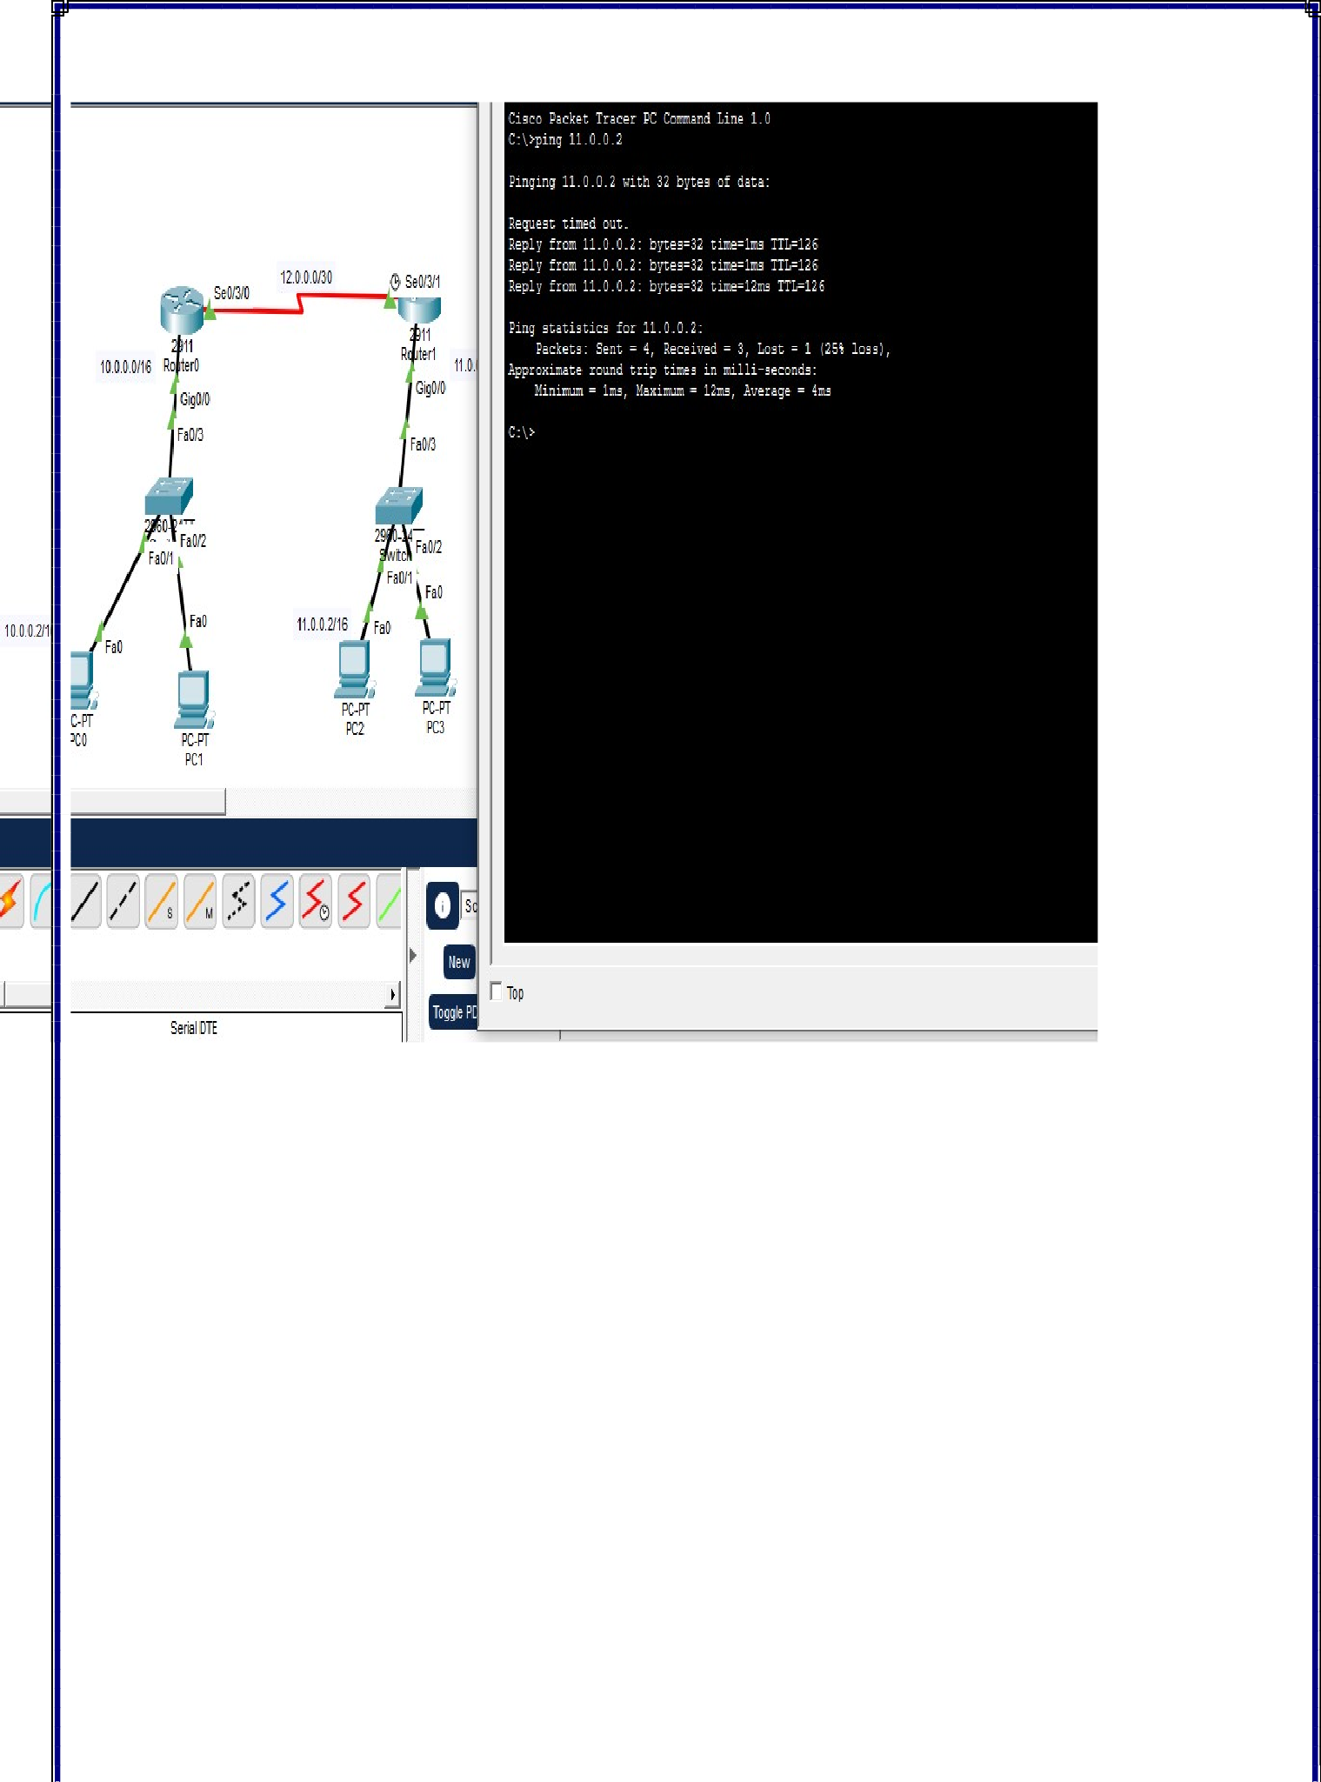

eNSP:
Topology:

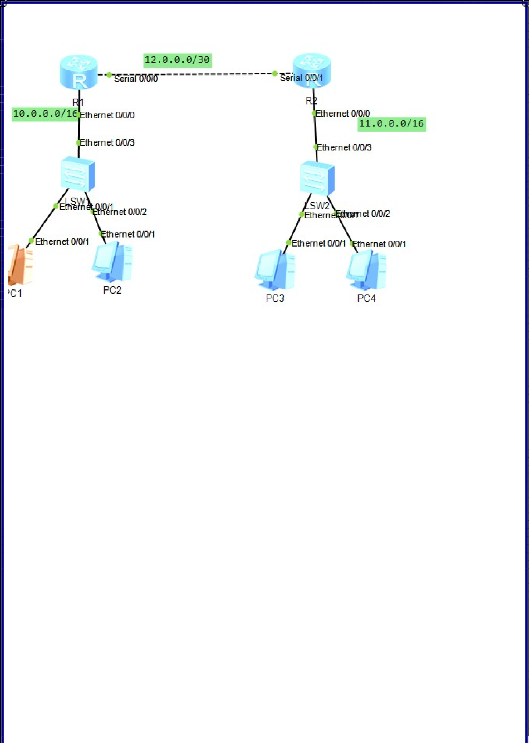

R1 Configuration:

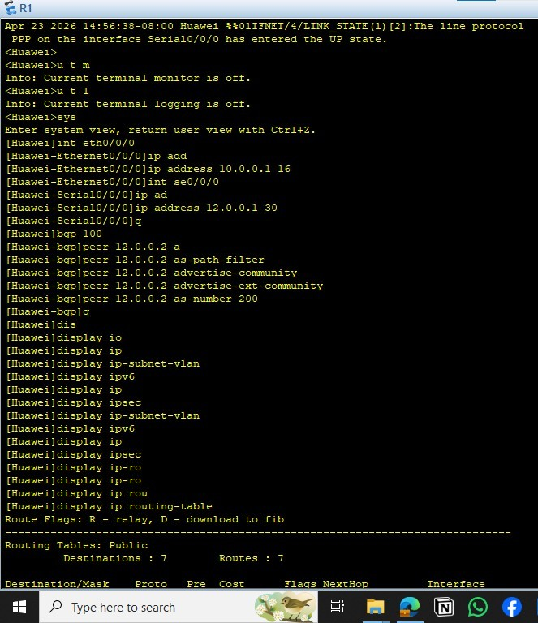

R1 Routing Table:

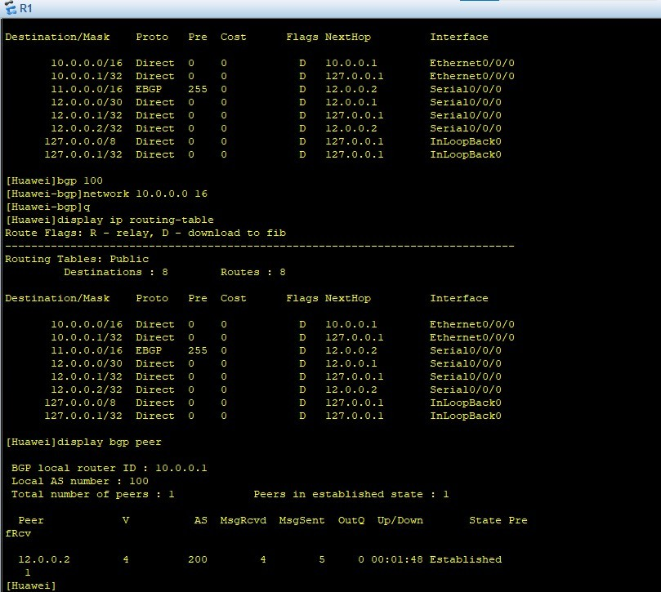

R2 Configuration:

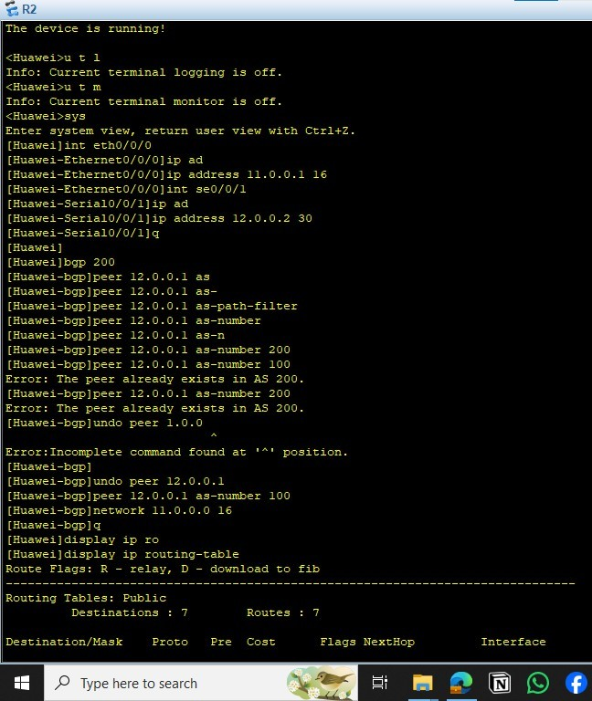

R2 Routing Table:

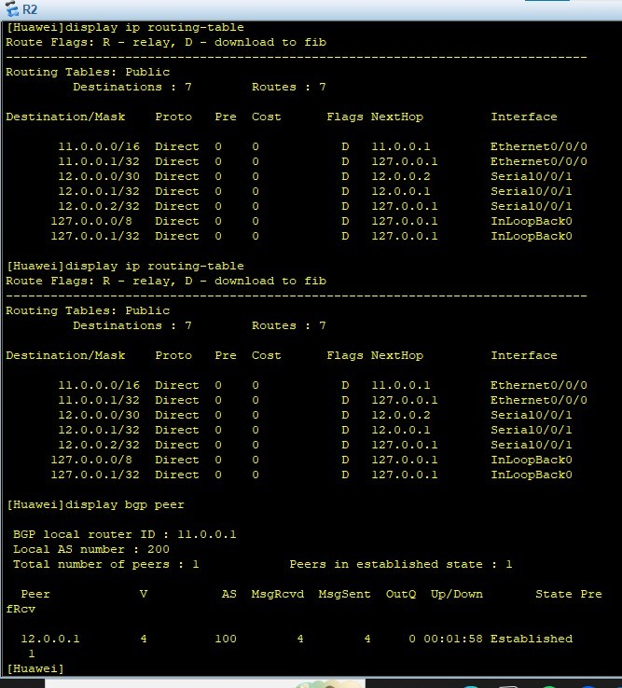

Testing:

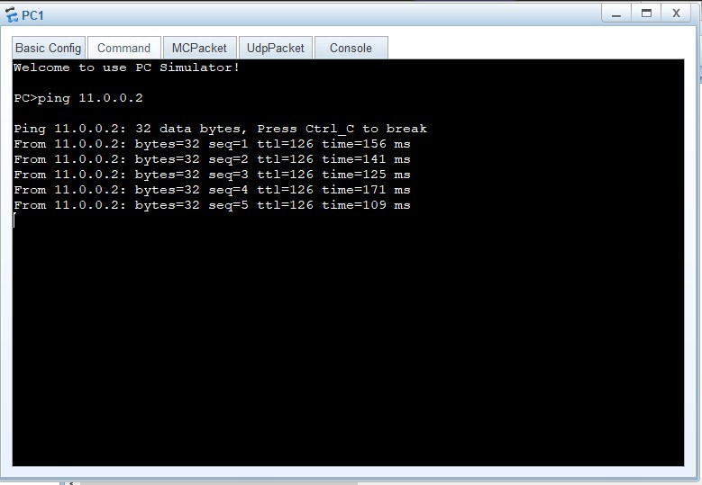

  - Conclusions:
Border Gateway Protocol (BGP) is the core routing protocol of the Internet, responsible for connecting different Autonomous Systems (AS).
It uses a path vector mechanism to select the best route based on attributes such as AS-Path and Next-Hop, rather than just the shortest path.
BGP is highly scalable and supports policy-based routing, which allows network administrators to control how traffic flows between networks.
However, it is more complex to configure compared to other routing protocols like OSPF or RIP.

